PYTHON PROJRCT 01

Sales Analysis
- Prepare Data for Analysis
• Begin by importing necessary libraries
• Read the csv file and store it as a DataFrame named df
• Print the DataFrame df and determine its dimensions
• Check for missing values in the DataFrame
• Verify that there are no non-missing values in the DataFrame
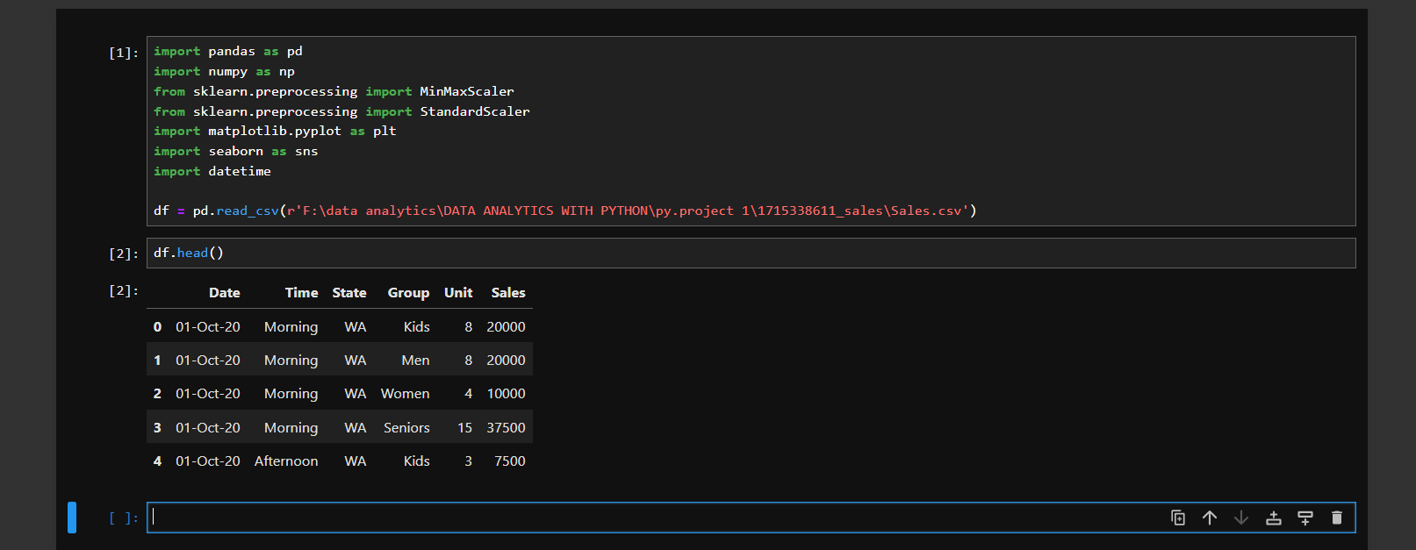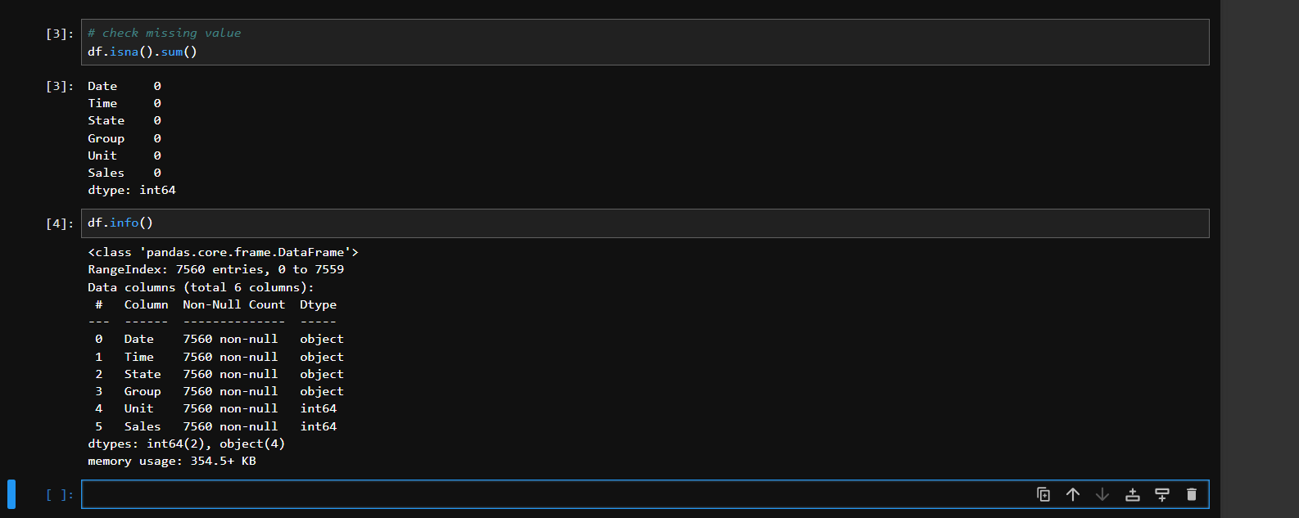

- Normalize Data for Analysis
• Create a new DataFrame called df_dataonly from the existing df object
• Create a normalize object
• Invoke the fit_transform() method, and pass this newly created object called df_dataonly and name the resulting object as normalize_data.
• The normalize_data object is an ndarray of 2 columns and 7560 rows. The first column is the Unit, and the second column is the Sales data. Normalization will scale the data in each column to a range between 0 and 1.
• Check the min and max values of each column. Min should be 0.0 and max 1.0, for Unit and Sales column.
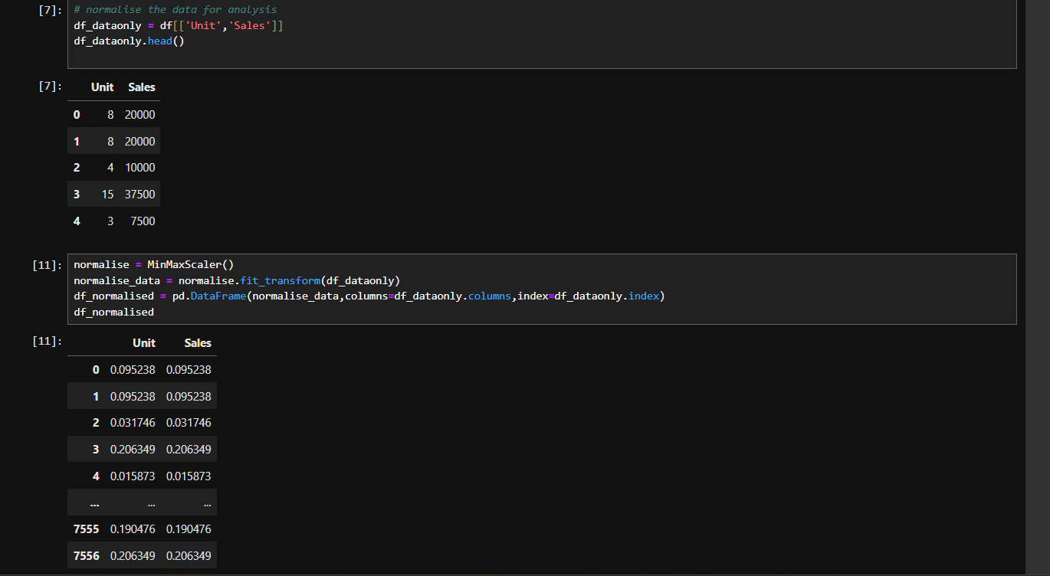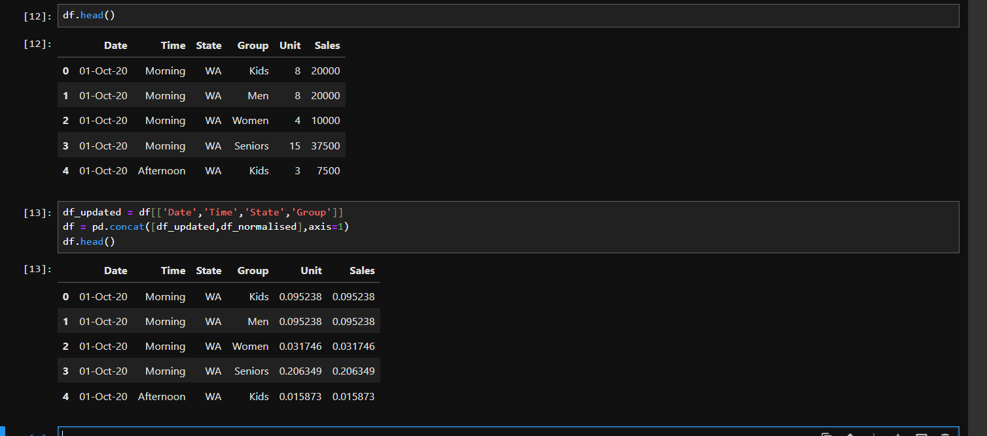

- Visualize Overall Trends
• Plot the Date versus Unit and Date versus Sales line plot for the entire season. Note the values of Unit and Sales are summed up for each day.
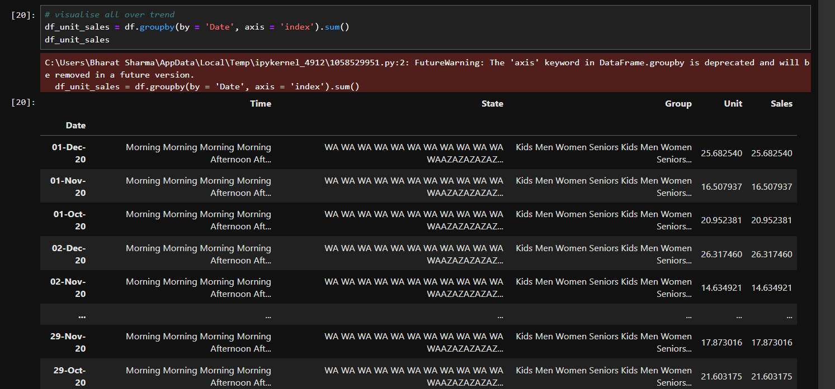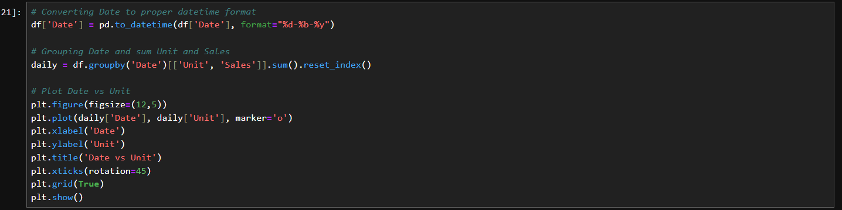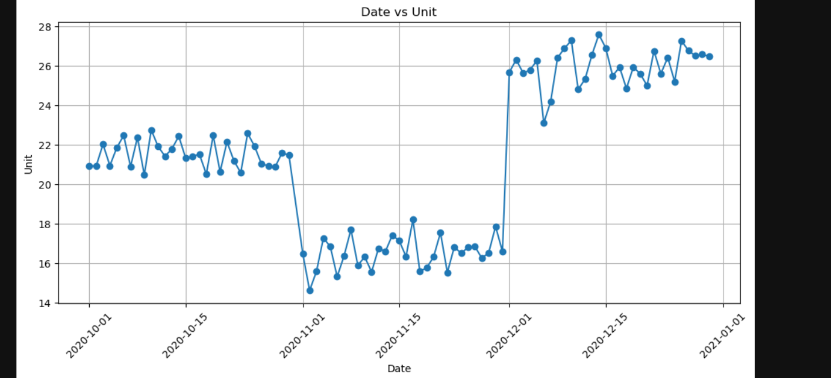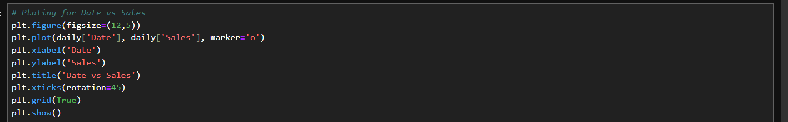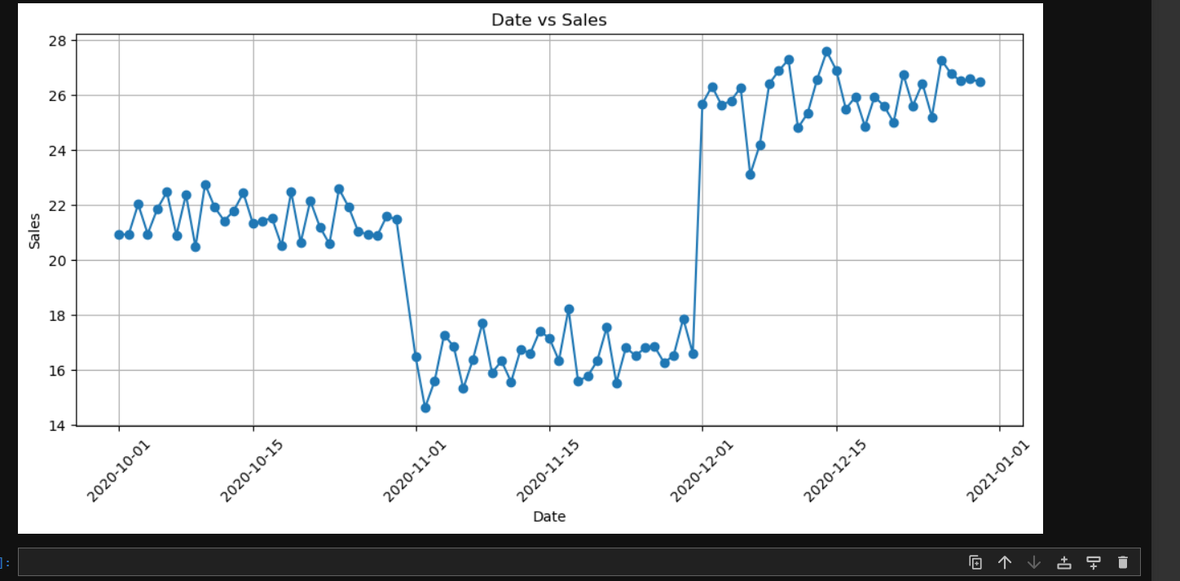
- Analyze Monthly Data
• Chunk this quarterly data into monthly data and perform the analysis. For each month, get the sub-DataFrame, using the loc feature of DataFrame, and pass the range by date.

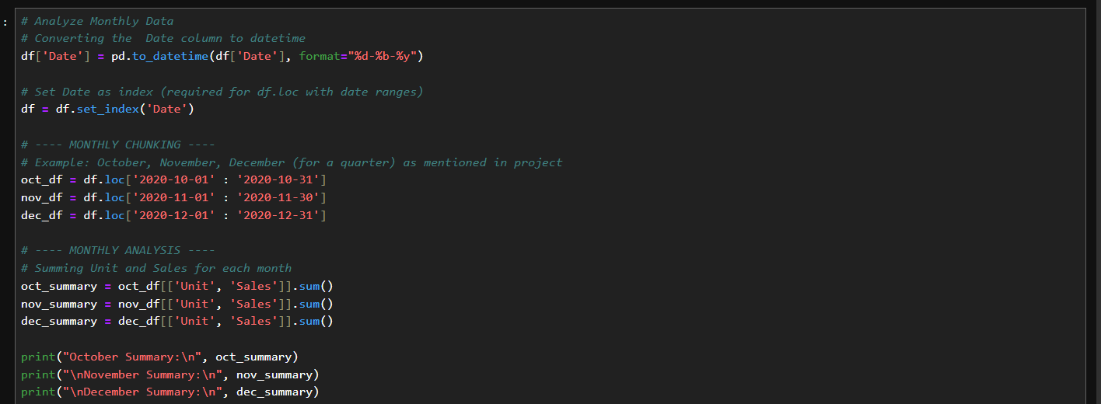
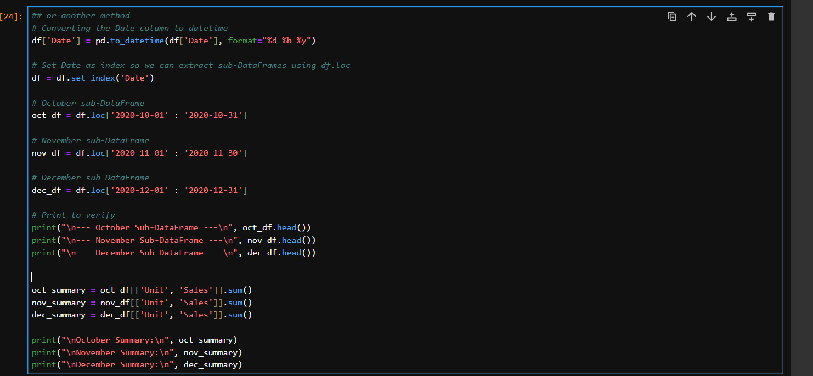
- Describe Data
• Describing the data will give you basic information such as count, mean, std (standard deviation), min, max and the quartiles. You will use the describe() command on the DataFrame to get it. All the values are for the entire three-month period.
• For each of the three months, you can invoke describe() on df_oct, df_nov, and df_dec.

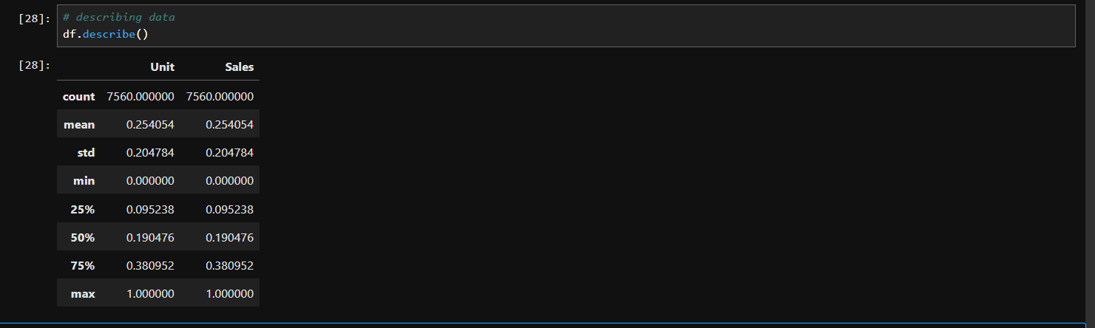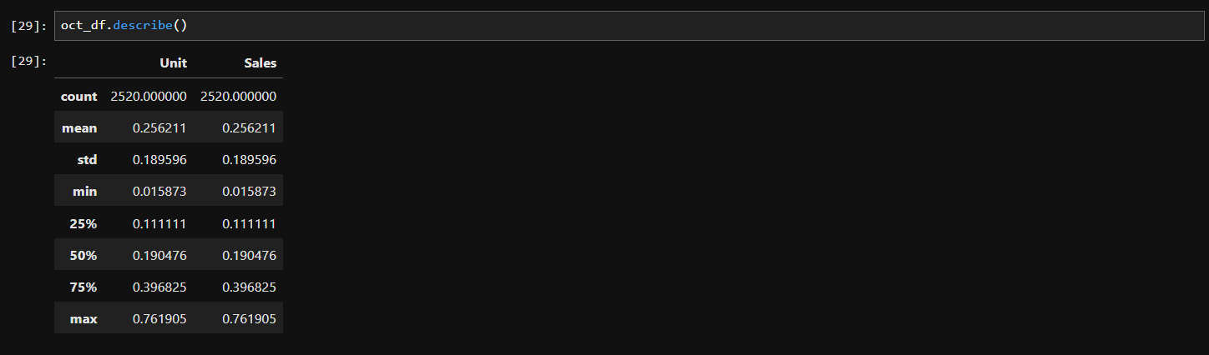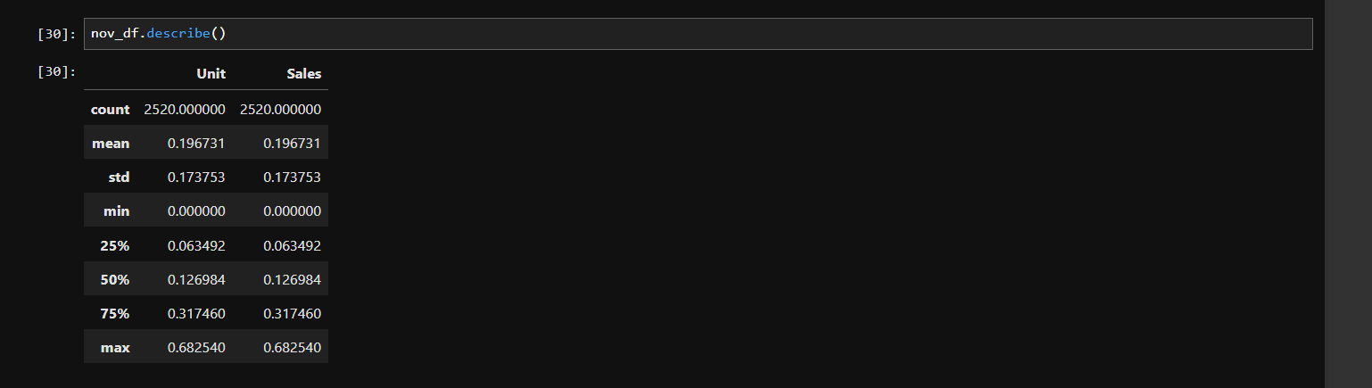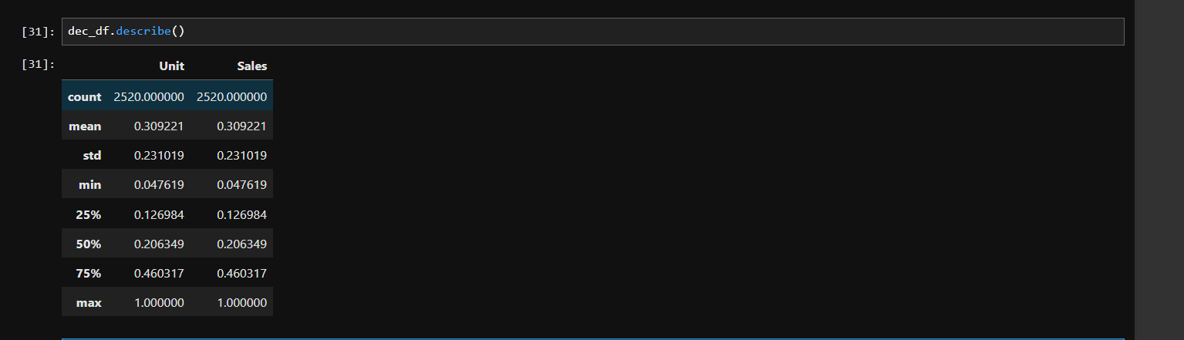

- Analyze Unit Data
• Unit Analysis
▪ You will use boxplots to visualize the distribution of units sold for each month.
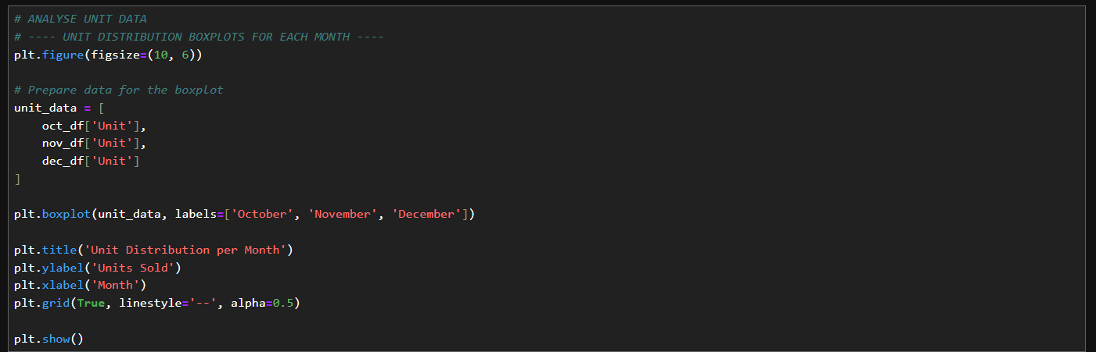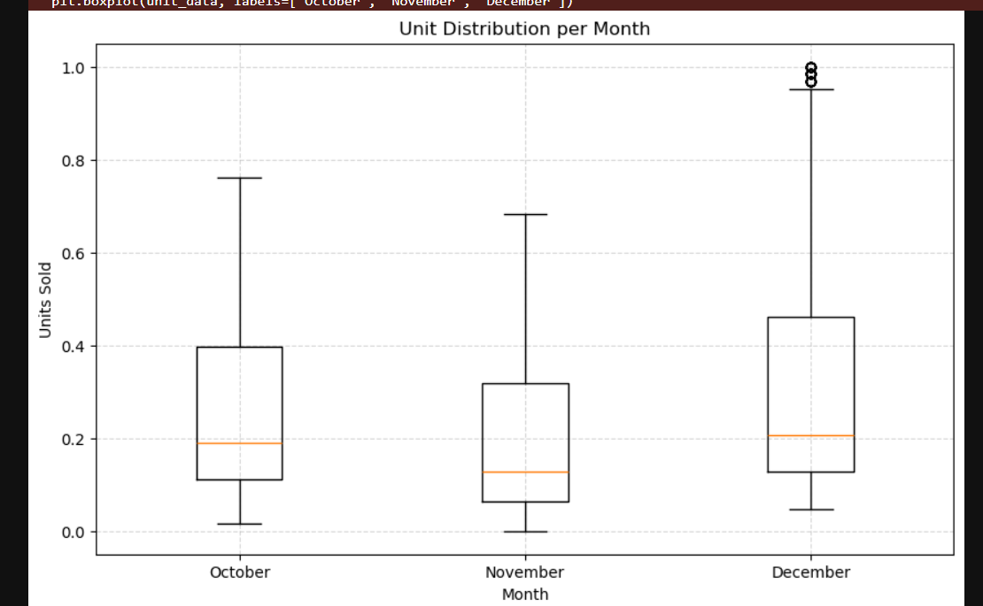
• Sales Analysis
▪ You will explore the distribution of sales revenue for each month.
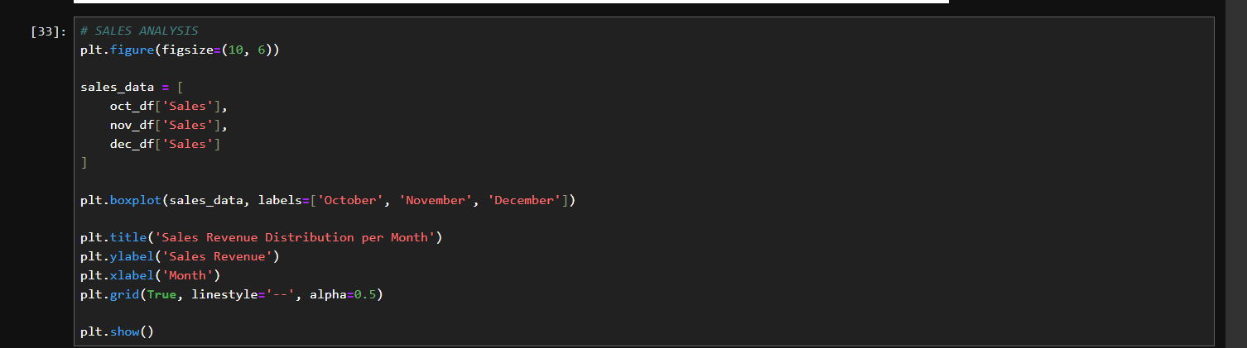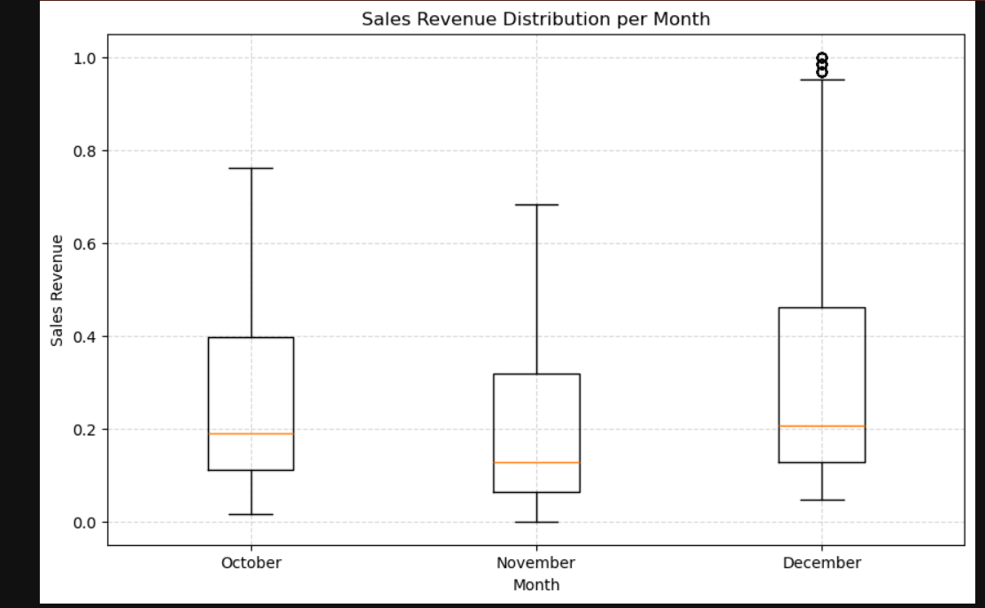

- Explore Monthly Plots and Analysis
• Overall Unit and Sales figures
• Units sold in October, November, and December
• Sales numbers for October, November, and December
• Consolidated 3-month sales plot
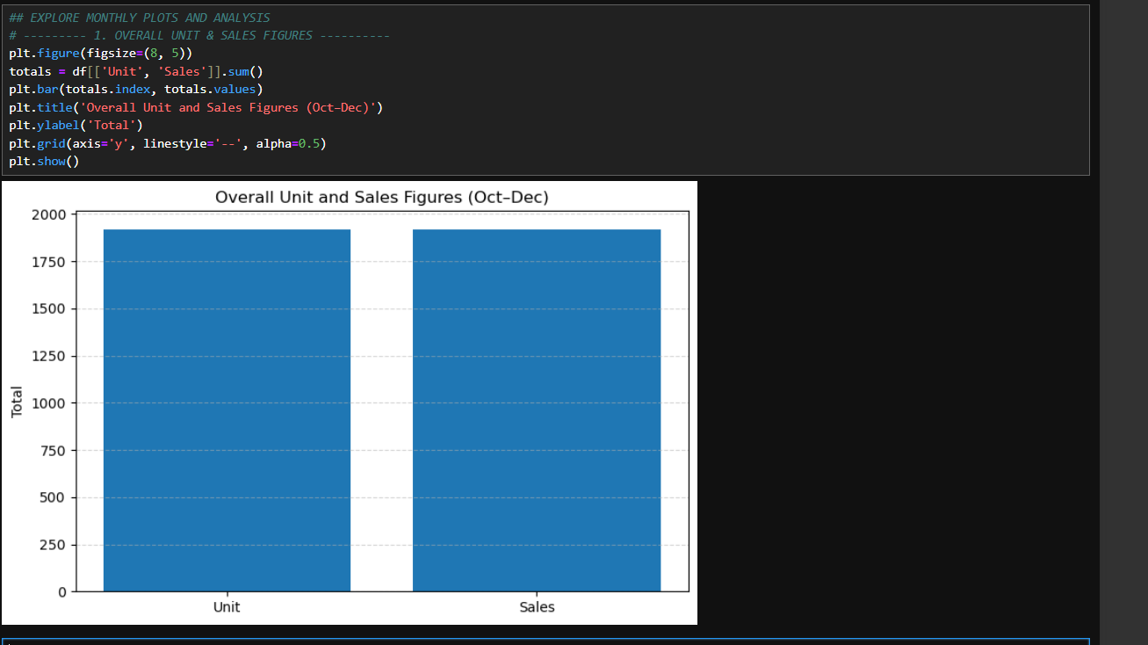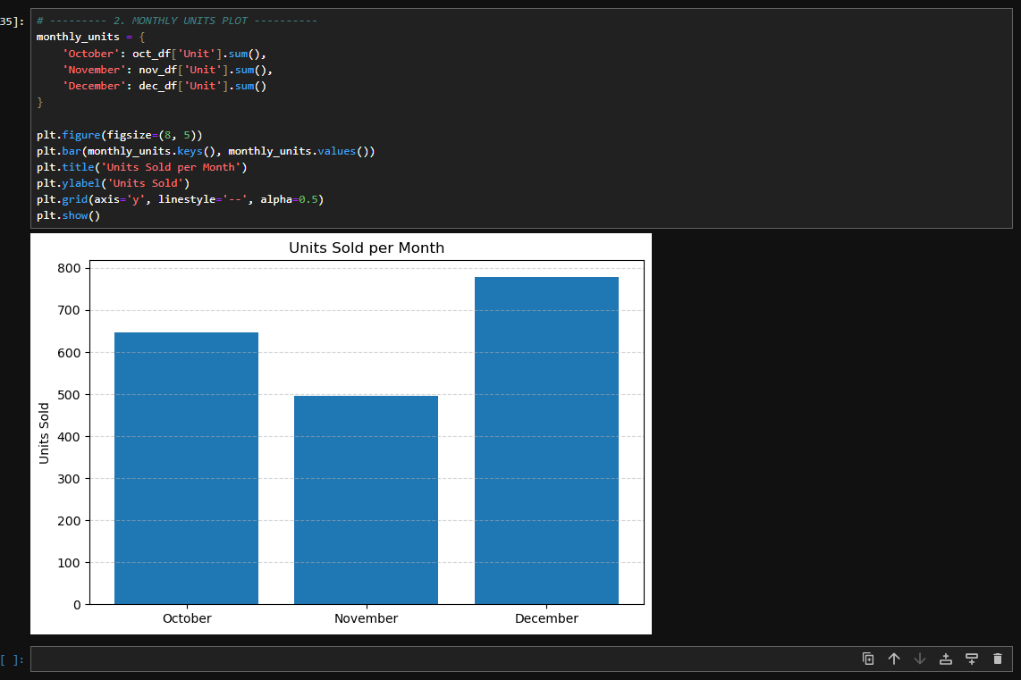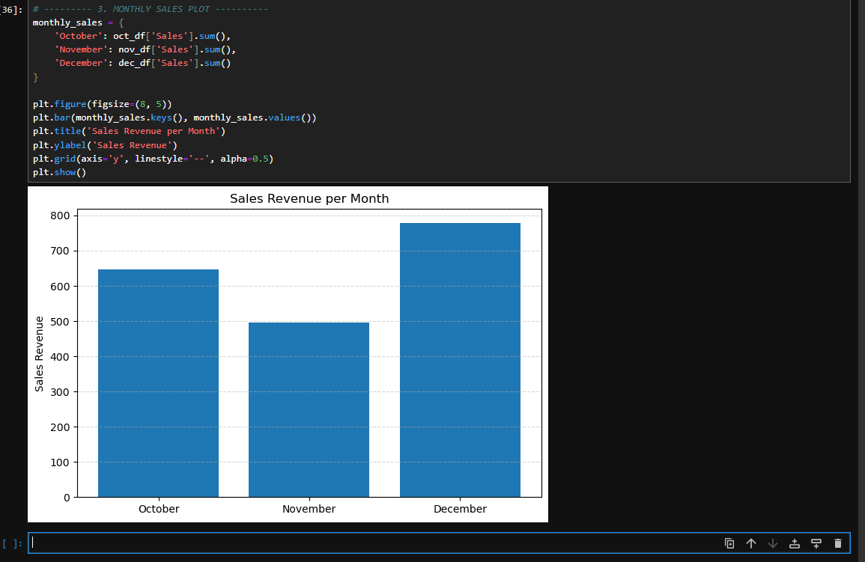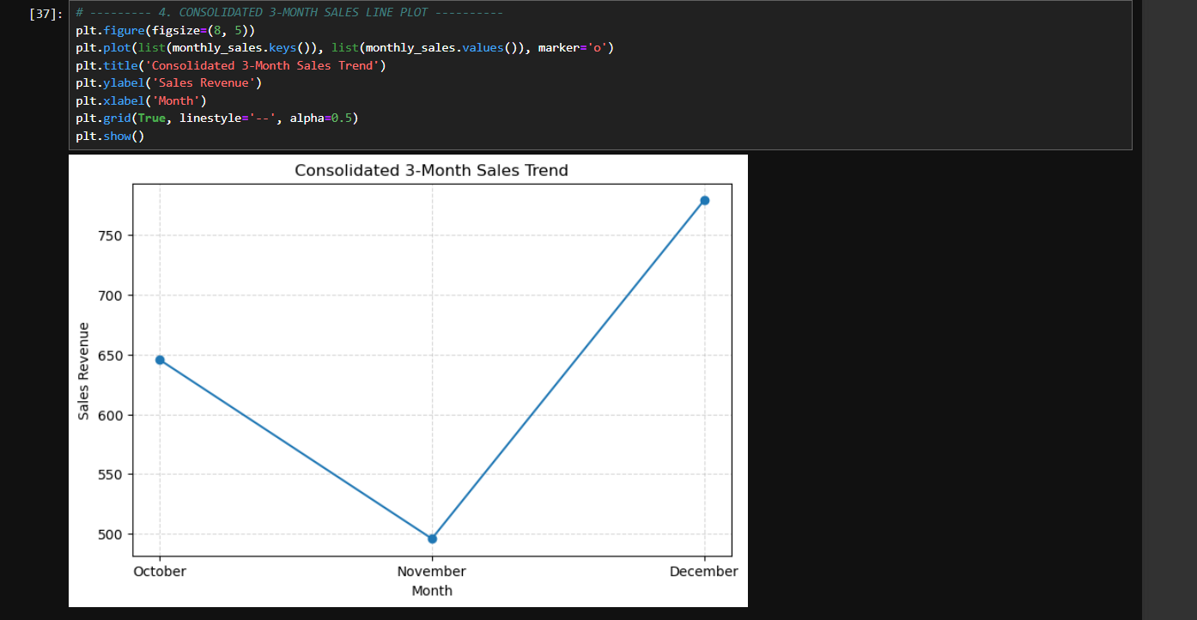
- Obtain a Comprehensive Snapshot
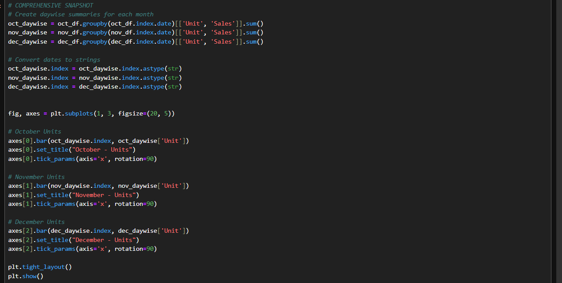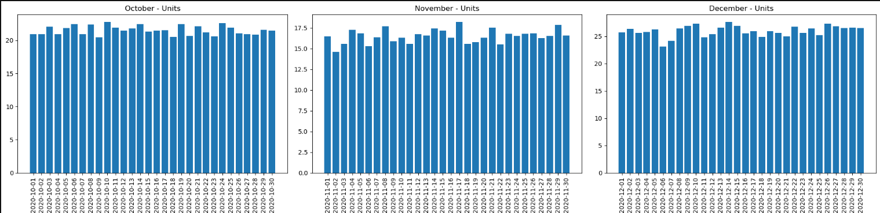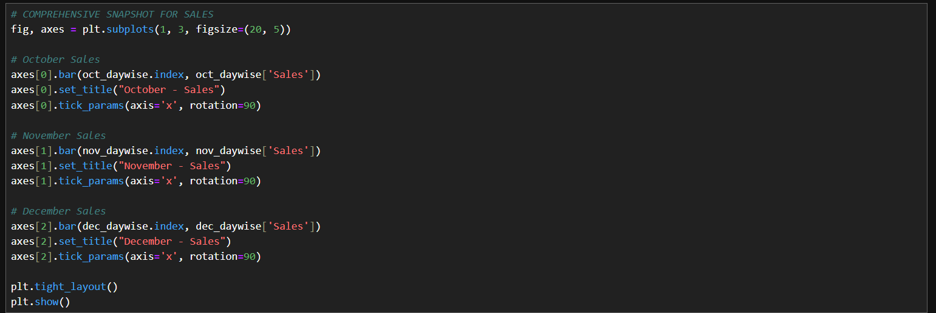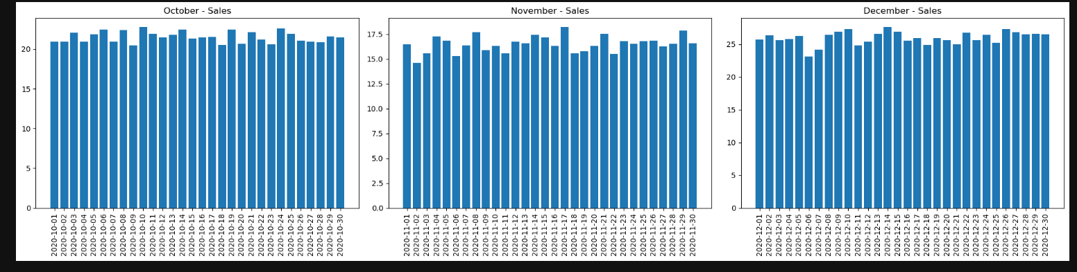
- Analyze Statewise Sales in the United States

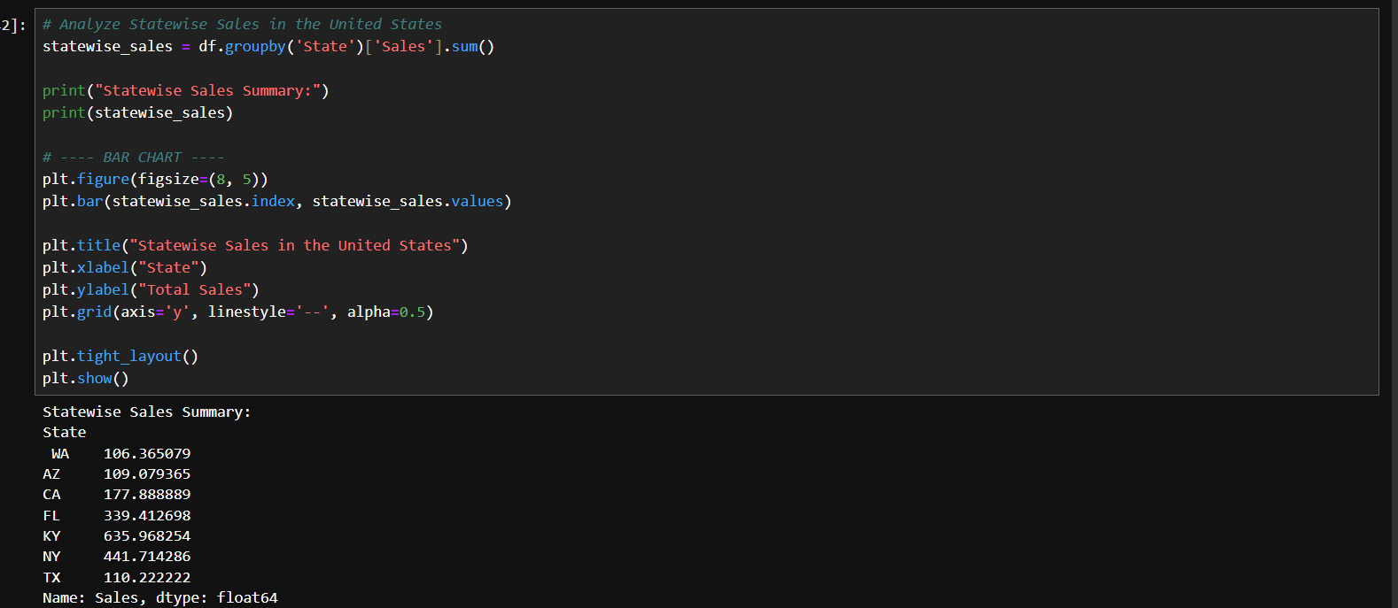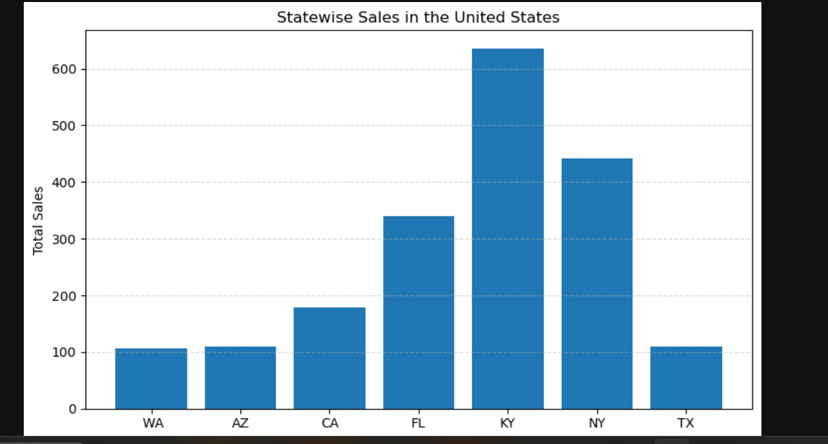

- Conduct Groupwise Analysis
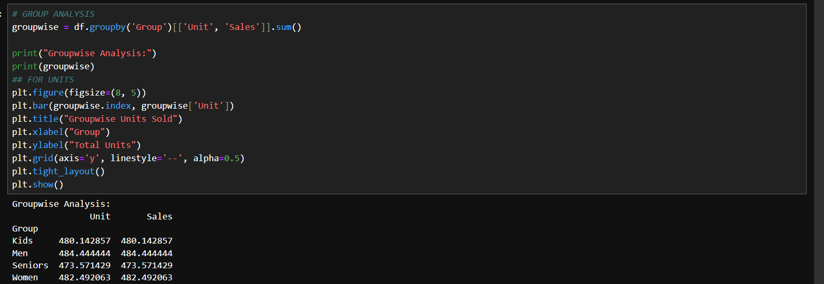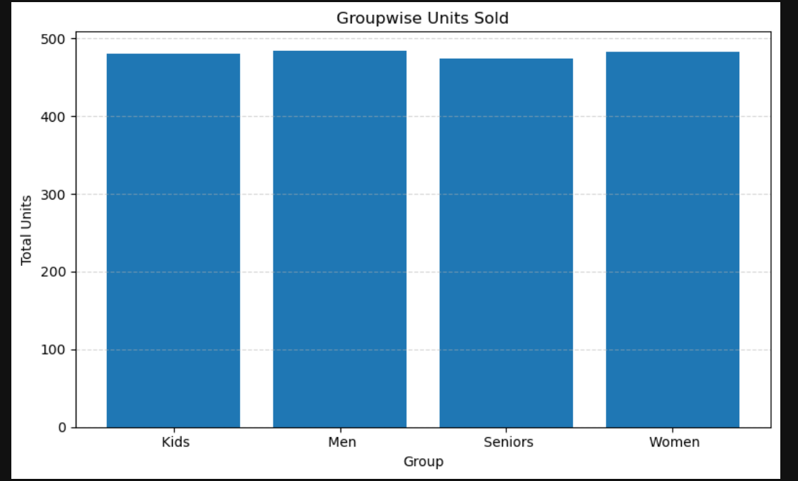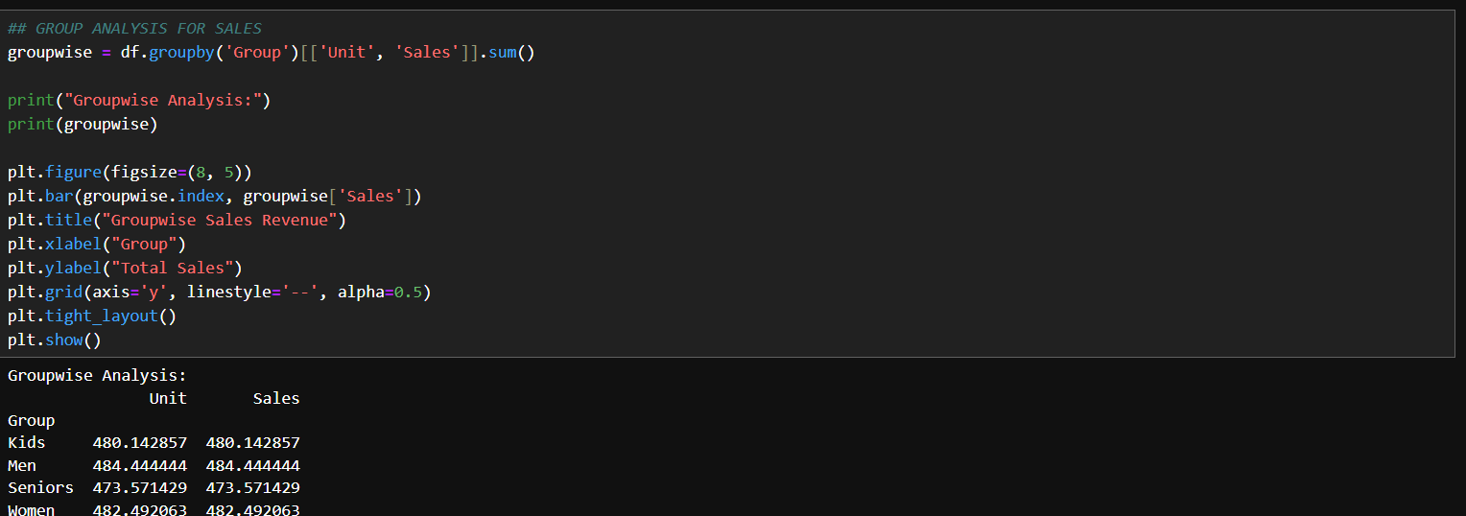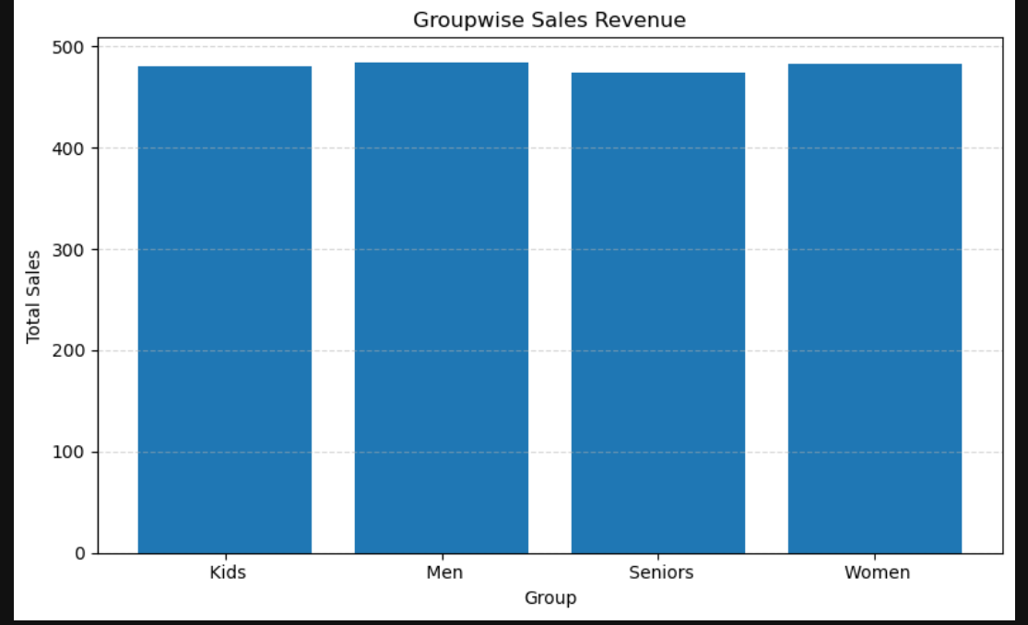

- Explore Timewise Analysis
